Project Planning Phase
Project Planning Template (Product Backlog, Sprint Planning, Stories, Story points)

Date | 20 Feb 2026
Team ID | LTVIP2026TMIDS74583
Project Name | BOOKNEST-WHERE STORIES NESTLE
Maximum Marks | 5 Marks

Product Backlog, Sprint Schedule, and Estimation (4 Marks)

Sprint | Functional  Requirement (Epic) | User Story  Number | User Story / Task | Story Points | Priority | Team  Members
Sprint-1 | Registration | USN-1 | As a user, I can register for the application by entering my email, password, and confirming my password. | 2 | High | Sudheshna
Sprint-1 | Registration | USN-2 | As a user, I will receive confirmation email once I have registered for the application | 1 | High | Saketh
Sprint-2 | Registration | USN-3 | As a user, I can register for the application through Facebook | 2 | Low | Lakshman
Sprint-1 | Registration | USN-4 | As a user, I can register for the application through Gmail | 2 | Medium | Prasanna
Sprint-1 | Login | USN-5 | As a user, I can log into the application by entering email & password | 1 | High | Mohan
Sprint-2 | Dashboard | USN-6 | As a user, I can view the dashboard with my recent orders and recommended books. | 3 | High | Saketh
Sprint-2 | Dashboard | USN-7 | As a seller, I can view the list of books I uploaded with edit/delete options. | 3 | Medium | Sudheshna
Sprint-2 | Dashboard | USN-8 | As an admin, I can see platform analytics including number of users and orders. | 5 | High | Lakshman

Project Tracker, Velocity & Burndown Chart: (4 Marks)
Sprint | Total Story Points | Duration | Sprint Start Date | Sprint End Date (Planned) | Story Points  Completed (as on  Planned End Date) | Sprint Release Date (Actual)
Sprint-1 | 20 | 6 Days | 18 Jan 2026 | 23 Jan 2026 | 20 | 23 Jan 2026
Sprint-2 | 20 | 6 Days | 24 Jan 2026 | 29 Jan 2026 | 20 | 29 Jan 2026
Sprint-3 | 20 | 6 Days | 30 Jan 2026 | 04 Feb 2026 | 20 | 04 Feb 2026
Sprint-4 | 20 | 6 Days | 05 Feb 2026 | 10 Feb 2026 | 20 | 10 Feb 2026
Sprint-5 | 20 | 6 Days | 11 Feb 2026 | 16 Feb 2026 | 20 | 16 Feb 2026
Sprint-6 | 20 | 6 Days | 17 Feb 2026 | 22 Feb 2026 | 20 | 22 Feb 2026
Sprint-7 | 20 | 6 Days | 23 Feb 2026 | 24 Feb 2026 | 20 | 24 Feb 2026
Sprint-8 | 20 | 1 Day | 25 Feb 2026 | 26 Feb 2026 | 20 | 26 Feb 2026

Velocity:
Imagine we have a 10-day sprint duration, and the velocity of the team is 20 (points per sprint). Let’s calculate the team’s average velocity (AV) per iteration unit (story points per day)

AV=620​≈3.33 story points/day

Burndown Chart:
A burn down chart is a graphical representation of work left to do versus time. It is often used in agile software development methodologies such as Scrum. However, burn down charts can be applied to any project containing measurable progress over time.

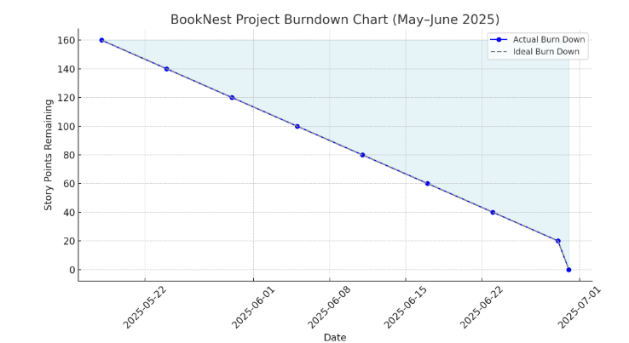

https://www.visua
l
-
paradigm.com/scrum/scru
m
-
burndow
n
-
chart
/

https://www.atlassian.com/agile/tutorials/burndow
n
-
chart
s

Reference:

t
https://www.atlassian.com/agile/projec
-
managemen
t

https://www.atlassian.com/agile/tutorials/ho
w
-
t
o
-
d
o
-
m
scru
-
wit
h
-
jir
a
-
softwar
e

https://www.atlassian.com/agile/tutorials/epic
s

https://www.atlassian.com/agile/tutorials/sprint
s

https://www.atlassian.com/agile/projec
t
-
management/estimatio
n

https://www.atlassian.com/agile/tutorials/burndow
n
-
chart
s

